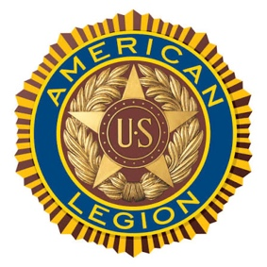
American Legion Monthly Newsletter
July 2026 Post 196

COMMANDER’S CORNER

As I put together my first newsletter as your Post Commander, I want to say what an honor it is to serve the members of our Post. I look forward to working alongside all of you as we continue to strengthen our Post and build on the legacy of those who came before us.
While I know there is much to learn as I settle into this new role, I am truly grateful to have so many longtime members who are willing to share their knowledge, advice, and guidance. I've heard it said, "You never want to be the guy after the guy." I know I will inevitably be compared to the outstanding Commanders who have served before me, but my goal is simply to serve honorably, lead with integrity, and do my best to support our Post and our members.
I would also like to extend my sincere appreciation to our immediate Past Commander, Terry Frasier, for his remarkable 13 years of dedicated service and leadership. Thank you, Terry, for your commitment and all you have done for our Post.
It was wonderful seeing so many of you at our Family Meeting on June 29. Your participation and fellowship are what make our Post such a special place.
As we prepare for our Independence Day celebration, please remember to bring candy for the parade and invite your neighbors, family, and friends to join us afterward at the Post. We'll be serving free hot dogs, ice cream, and root beer (while supplies last). One of the highlights of this year's celebration will be the arrival of a Black Hawk helicopter following the parade. We look forward to celebrating America's birthday with all of you!
Thank you for your continued support, your service, and your dedication to our American Legion family. Together, we will continue to honor our veterans, serve our community, and uphold the values that make our Post strong.
Respectfully,
Allen Shook
Post Commander
American Legion Post 196

LEGION PICTURES:
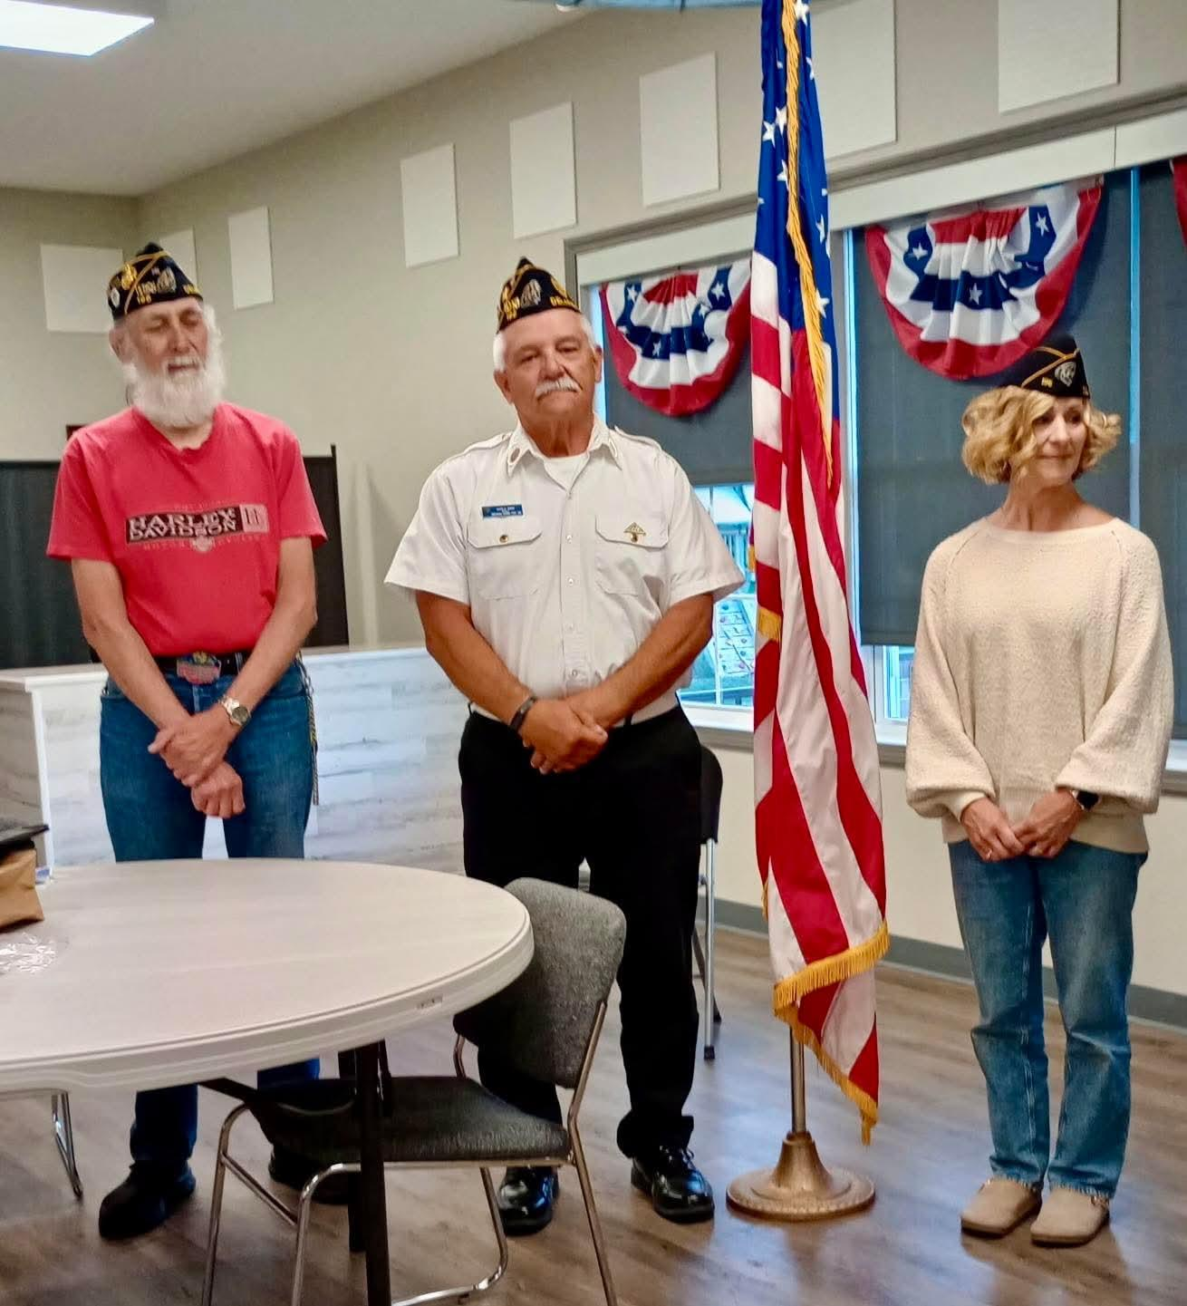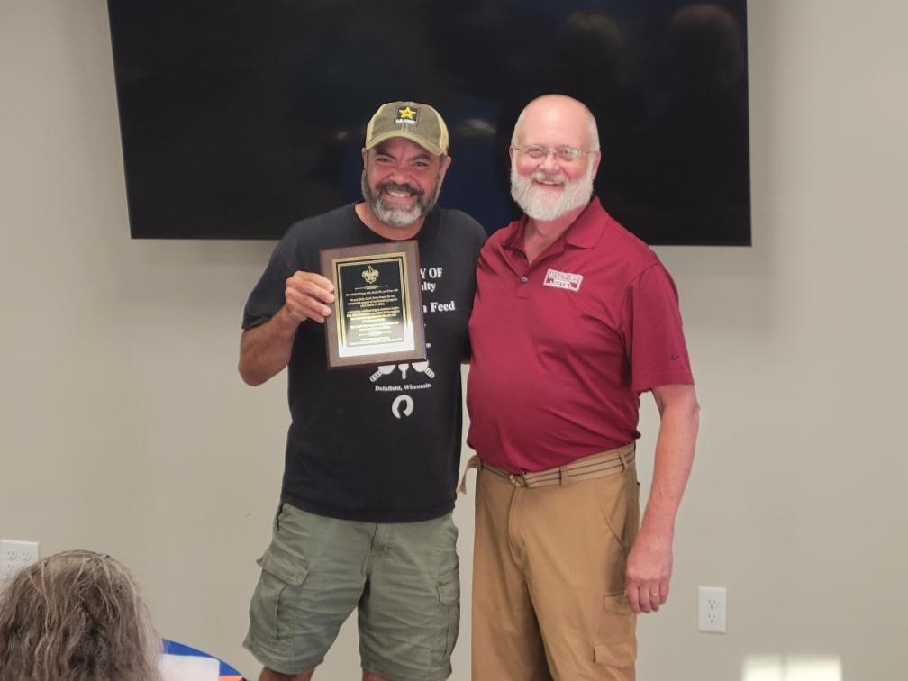

AUXILLIARY REPORT 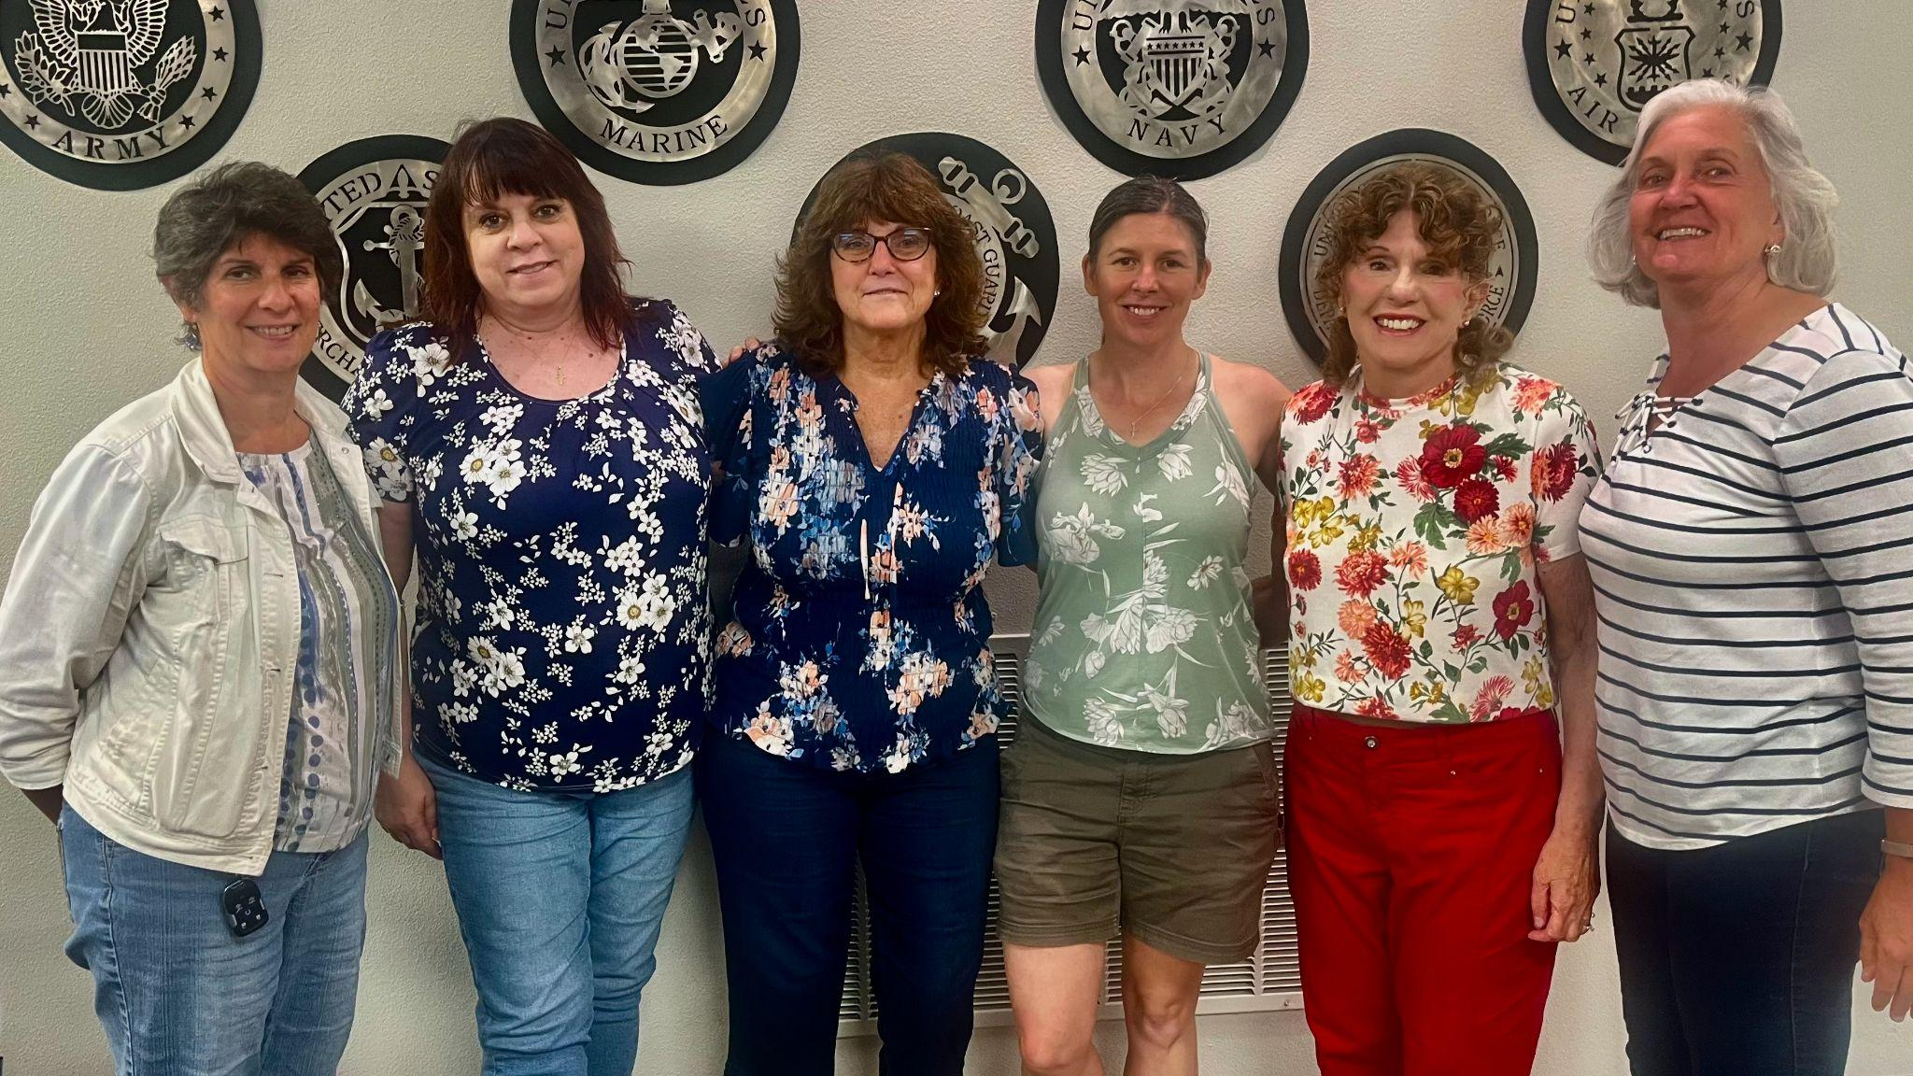
Hello all, your auxiliary group is busy planning for summer events and of course helping at all the legion events.

Our last meeting was Monday June 8th for our summer potluck picnic attended by 25 members, as well as a guest who is considering joining.

For those that attended the June 29th Family meeting you got to meet the Auxiliary sponsored pups Ace and Sierra. I will continue to share updates on progress as they come in.

By the time you read this the July 4th parade and legion event will be upon us. We have been busy signing up volunteers and purchasing food and beverages to be handed out ‘free’ to all our parade watchers. You can donate candy (no chocolate) to be thrown during the parade up until July 3rd. Thanks to all our generous donors who contributed monetary donations towards the food.

Consider signing up to donate blood for the July 15th blood drive 1-6pm. Kettle Moraine is hosting this event.

Unfortunately, schedules did not work out for the July 25th ‘Brats at the Pig’ fundraiser so this has been cancelled.

Delafield National Night Out is Aug 4th 6-8pm. Sarah and Cathy will be representing the legion and handing out small flags and candy.

Many of us auxiliary are also on the golf committee and volunteering for the Aug 28th 15th annual golf outing.

And believe it or not the wine committee will meet before you know it for the annual wine and beer tasting on Nov 7th.

Looking forward to seeing you all at the legion and supporting the other Legion Family events coming up.
Mary Steinmueller
President, American Legion Delafield Auxiliary
Honor our Country, Support our Veterans

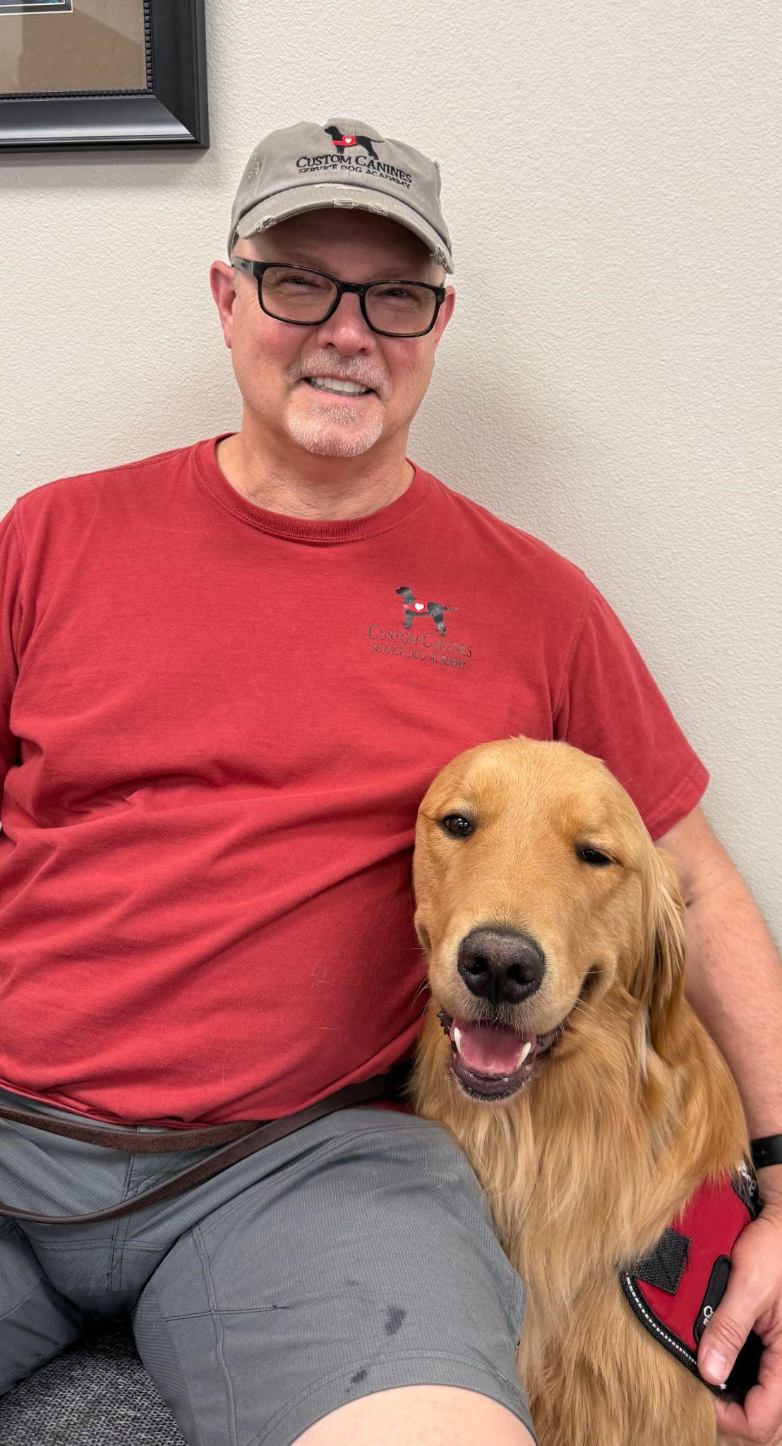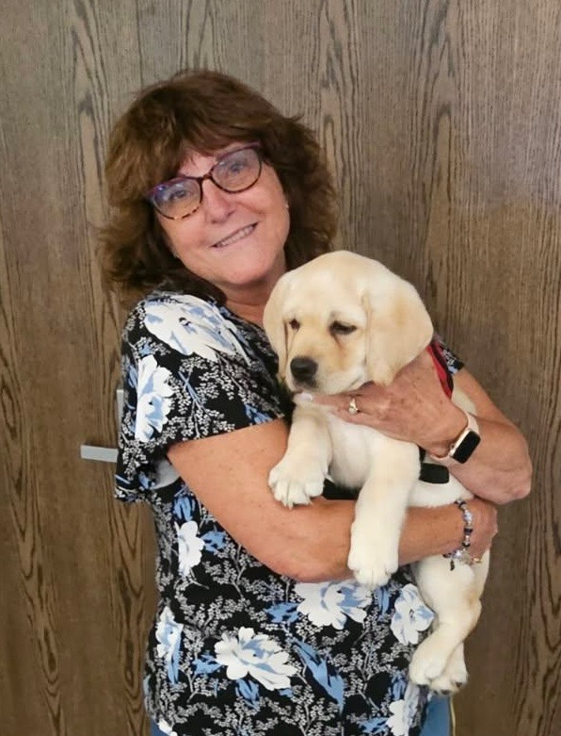MEET ACE and SIERRA

S.A.L.S REPORT

Well Summer is finally here…I hope it’s warm enough for everyone.

Our monthly membership meeting was held on June 1st. 2026 with 13 members in attendance.

We had a guest, Our new Legion Post 196 Commander, Al Shook. Commander Shook introduced himself to the SAL’s and thanked us for all of our hard work in the past and looks forward to working closely with us in the future.

Our May Meeting Minutes and Financial Report were read, voted on and
approved.

We voted on and approved a new member, Robert Wurzel. Welcome Robert!!
We are up to 82 members now!

More great news, SAL’s Member Mike Trier has volunteered to be the Legions new house agent, bar manager and restaurant manager. Thank you Mike for taking on this important role at our post.
Also, Thank You to Terry Fraizer for his many years of dedication and hard work previously in that role.

We will make our annual donation to the Wounded Warrior Bass Tournament of $500 in August and our annual donation to Dry Hootch of $1000 in September.
Dennis Schuetz reported that our Annual SAL’s Golf Outing made a $4437.00 profit which was a record year. Thank You to Dennis for chairing this event as well as all of those that volunteered and participated.
We already have people signed up for next year and will discuss possibly expanding next year as well.

1st Vice Commander, Steve Reardon announced that our Consolidated Report has been sent in to the state by Steve Reardon. It is a lot of work putting that required document together so thank you Steve.

Steve is also working on a SAL’s Night Out, just a fun night out at a Dockhounds game. More details to follow.

The Delafield Annual Block Party will be held July 16,17 & 18 and the Son’s will be there holding our Annual Corn Roast.
Set up will be on Thursday at noon and we will sell corn Thursday, Friday and Saturday evenings. Clean up will be Sunday at noon.
Help will be needed all four days. We will have sign up sheets at our July Meeting.

We have set a couple dates for upcoming annual events. The SAL’s Annual Tailgate Party will be October 4th at noon for the Packer-Tampa Game.
The SAL’s Annual Chili Contest will be held on December 6th at noon for the Packer-Saints Game.

This was reported last newsletter but in case you missed it our New Officers were elected as follows:
Commander - Jerry Nuernberger
First Vice Commander - Steve Reardon
Second Vice Commander - Dan Knickelbein
Adjutant - Bruce Roberts
Finance Officer - Jerry Nuernberger
Historian - Kent Atwell
Chaplin - Tom Kerwin
1st Sergeant at Arms - Dennis Schuetz
2nd Sergeant at Arms - Ed Marek
Judge Advocate - Pat Trier
Quartermaster - Tim Luetzow
Thank You to all that have volunteered to serve the Delafield SAL’s.

We are going to be ordering t-shirts for us to wear at our events. Place your order at our next meeting if you are interested. The cost will be around $15 each.

Tim will send out invoices for billboards this year and we have a new billboard sponsor, IGA Financial Group. There is still room for more sponsors if anyone knows of a company that may be interested, please let Tim or Jerry know.

The bar is looking for help with fish fries on the first Friday or any Friday of the month. There is a sign up sheet at the bar.

Don’t forget to spread the word regarding our 4th of July Parade!!! Lord willing we will have the Blackhawk Helicopter landing at our post. If you haven’t seen it in person, I highly recommend being there. It really is one of the coolest things you’ll ever see!!

Our next scheduled monthly meeting is Monday, July 8th 2026 at 6:30pmat the Delafield Legion.

Until Next Month….Take Care & God Bless!!!

Respectfully Submitted,

Dan Knickelbein

Chaplain’s Corner – July 2026 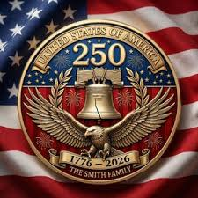

July brings out the very best of our American spirit —
flags flying high, families gathering, and the unmistakable pride that fills our streets during the Independence Day parade.

This year carries an even deeper meaning as we celebrate the 250th birthday of
the United States of America. A quartermillennium of courage, sacrifice, and hope — carried forward by generations who believed in the promise of freedom.

Post 196 is honored once again to welcome the Black Hawk helicopter back to our
baseball field. Its arrival is more than a thrilling moment; it’s a powerful reminder
of the service and dedication that have safeguarded our nation through these 250
remarkable years.

But celebration also calls for care. Summer heat can be relentless, so please stay
hydrated, take breaks, and keep an eye on those around you. A simple gesture — a
cold drink, a shaded seat, a quick checkin — can make all the difference. Patriotism isn’t only found in parades and ceremonies; it’s found in how we care
for our neighbors and fellow veterans.

This Post continues to shine as a community of strength and compassion. May
your July be filled with joy, safety, and gratitude for the blessings we share —
especially in this historic year for our nation.

God bless each of you, and God bless America at 250. Your Chaplains stand ready
to support you in every season.

Your Chaplains are:

Contact the Legion Chaplain – Neil Rand at (262) 646-3126 nrand@wi.rr.com
Contact the SAL Chaplain – Tom Kerwin at (262) 370-7450 tkerwin@wi.rr.com
Contact the Auxiliary Chaplain – Barbara Doerfer at (414) 333-4891 jbedoerfer@gmail.com

Scouting America Units Troop 49, Crew 196, and Pack 196 are Chartered by the Delafield American Legion.

Troop 49 JUNE 2026:

Eleven scouts and 6 adult leaders went on the Waterfall Campout. They stayed on one of the leader's land in Pembine, Wisconsin. There's a very cool area there with several hammock chairs for lounging and a great cooking area. They baked bread on their Wompum Sticks. And they visited several waterfalls and a petting zoo.

The Troop gathered at the Legion to sort through about ten large bags of flags meant for retirement. The scouts sorted the flags into piles of cotton and synthetic flags which were laid out on the litters in preparation for the Flag Retirement on Flag Day. On Flag Day at 5pm, the scouts participated in the Flag Retirement ceremony with the Legion Honor Guard.

Afterwards, four new scouts were taught the proper way to raise and lower the flag to fulfill one of their rank requirements.

Twelve scouts attended week long summer camp at Camp Long Lake in Saint Cloud, Wisconsin (near West Bend). The scouts were very active all week. The scouts participated in the Camp Wide Relay, Auqafest competitions in the lake, campfires, cooking, and lots of fun. The Troop was led by Elliott who planned many activities for the Troop which created a sense of community and working together towards goals. One scout completed the Mile Swim (at 6am!). The scouts earned the following merit badges: Cybersecurity, Rifle, Motorboating, Weather, Oceanography, Camping, Personal Fitness, Athletics, Swimming, Communications, Environmental Science, Emergency Preparedness, First Aid, Wilderness Survival, Archery, Geocaching, Sustainability, Bird Study, Space Exploration, Plant Science, Fishing, Exploration, Canoeing, Engineering, and Nuclear Science. The Troop greatly appreciates the Scoutmaster and three adult leaders who spent the week at camp supporting the scouts.

Troop 49 JULY schedule:

The Scouts are looking forward to marching in the Delafield Fourth of July Parade. Each will receive a special America's 250th Birthday Flag lapel pin as a gift from the Troop.

The Troop will be camping at Saint Johns Military Academy and helping at the Cub Scout Day Camp. The Troop will support the teaching of Swimming requirements and also Geocaching. The Troop campsite will be visited by the Cub Scouts so they can see what the set up looks like and to share a camp meal.

Two of our scouts are going to the National Jamboree in West Virginia as part of the contingent out of Potawatomi Area Council. This event only happens every 3 years. It is ten days of fun, meeting scouts from across the nation and world. Scouts can participate in many activities including rafting, mountain biking, ziplining, climbing, and sessions where they can meet with educators, mayors, legislators, and community leaders as part of the Americana Extravaganza Civic Engagement program. Most people who attend Jamboree think it is an outstanding experience.

Cub Scout Pack 196, for boys and girls in kindergarten through 5th grade, meets twice a month throughout the school year at Dousman Elementary. They recently held their Graduation to their next ranks. They will be attending the Cub Scout Day Camp at Saint Johns Military Academy in mid-July. There are currently 10 Cubscouts in the Program and more will certainly join in Fall.

Garage News: We have received bids for site excavation, and the concrete pad, and materials. We are exploring costs for upgrading the electrical service. We are seeking more bids and looking for community partners to help fund the garage build. Things are in the works. Please contact Jennifer if you want to be involved in the new garage build.

Yours in Scouting
Jen McCarthy
Troop 49 Committee Chair
Crew 196 Advisor
Pack 196 Committee Chair
mccjen49@yahoo.com

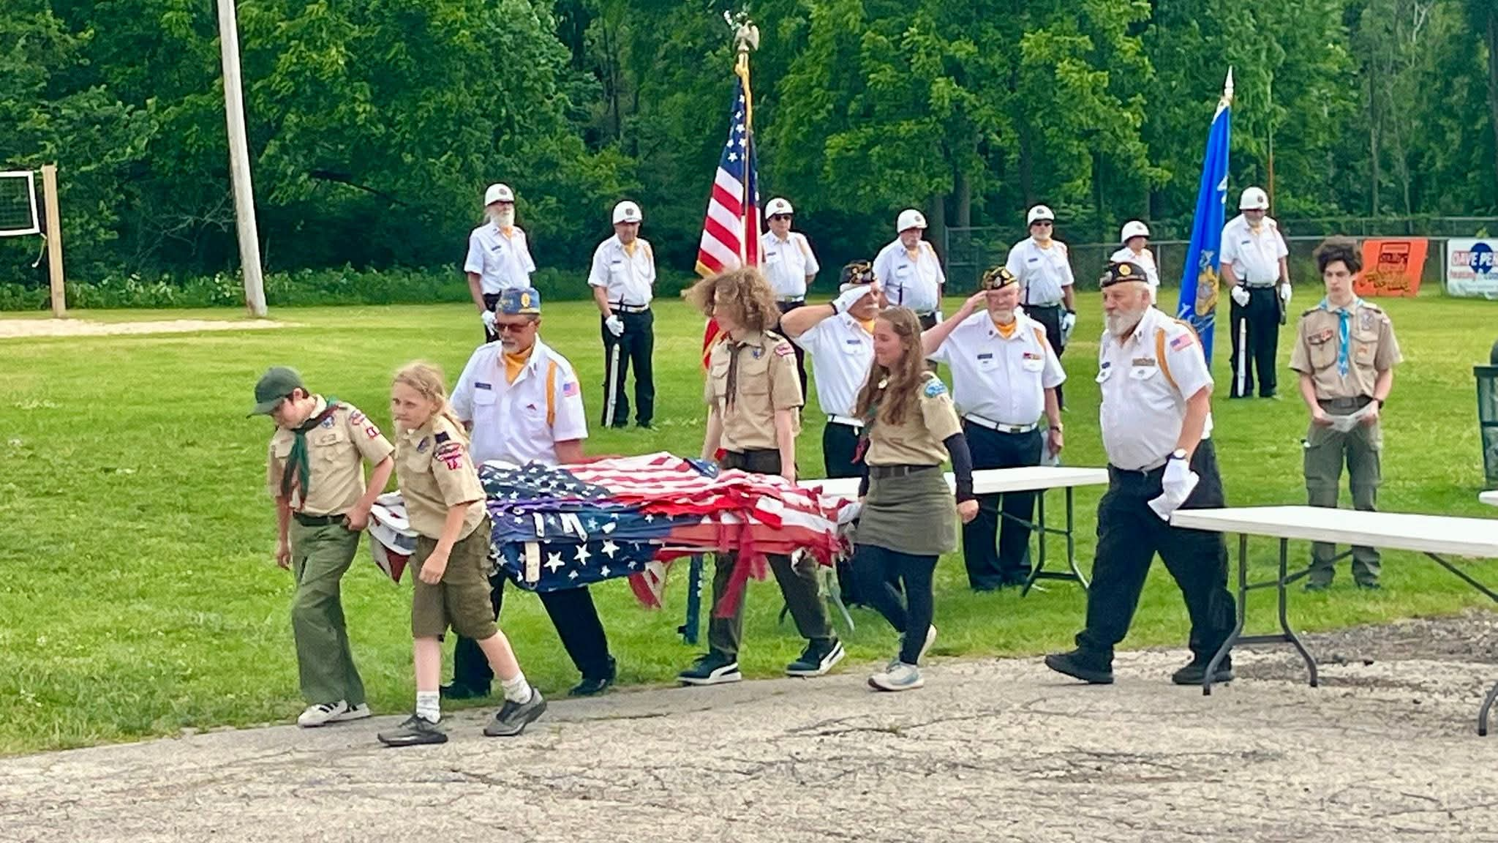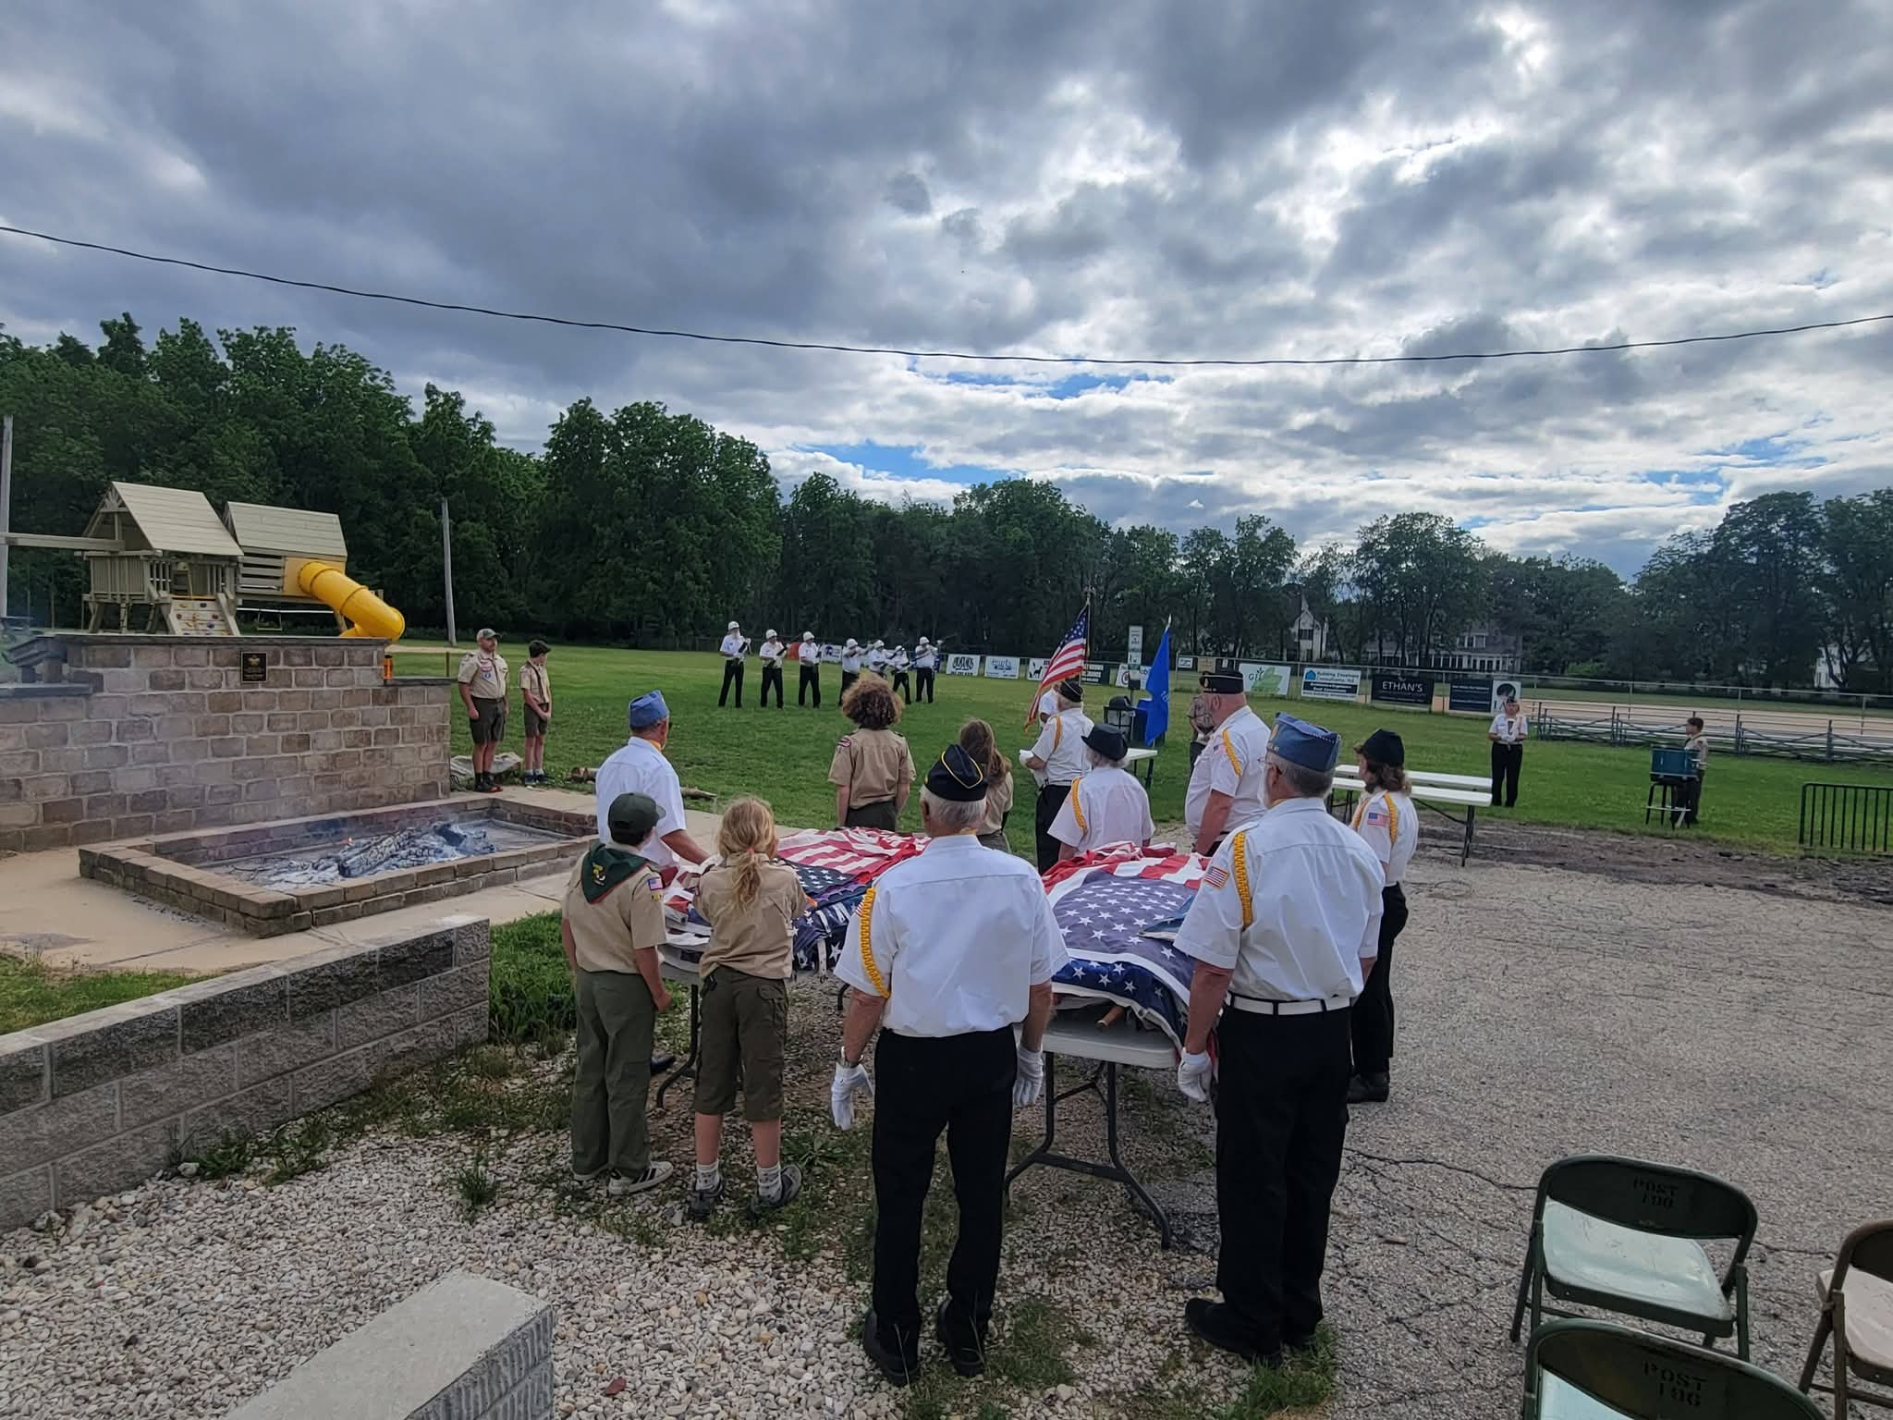
2nd Vice Commander: As I step into the role of 2nd Vice Commander, I wanted to say THANK YOU to Buff for all that he has done throughout the years serving in this position along with the countless other tasks that he has done for our Post. I am excited to serve my fellow legionnaires, auxiliary members, SALS, and community during the upcoming year! Thank you for your grace and patience as I take on the different tasks associated with this position.

With Much Appreciation,

Stephanie Todd
2nd Vice Commander
American Legion Post 196

