THE AMERICAN LEGION POST 196

December
2025
Delafield Post No. 196
333 Lapham Peak Road
Delafield, Wisconsin 53018

Meetings:
Clubhouse Opens:
About 1 hour before Business Meetings
Legion / 3rd Monday
December 15 1900 hrs
Sons/ Tuesday
December 1 1830 hrs
Auxiliary/ 2nd Monday December 8 1830 hrs


The World’s Largest Veteran Organization
Post 196
Delafield, Wisconsin,

“The Spirit of 196”
Clubhouse phone - 262-646-3930
The American Legion

Commander’s message for December 2025

Hello Legion Family Members,

I hope everyone had a enjoyable and relaxing Thanksgiving with friends and family. Now that we have had our first big snowfall, Winter is in full swing. Christmas is just around the corner.

This next Sunday the Sons will be having their Chili Cook-Off. Come on down and join us by either enjoying delicious chili or you can enter your own chili for the chance to win some money be named best chili in the cook-off! The Packer game also starts at 3:25pm that Sunday. Hopefully they beat “Da Bears” and keep on rolling with another win.

At our last meeting I mentioned that we will be discontinuing “Taco Wednesday” at the end of the year. It’s been a good run for over 20 years. It’s time to look at something new. We will keep you posted in the coming new year.

Due are due again for the 2026 year. If you have not paid your dues, please do so. If you have any questions on whether or not you have paid your dues, please contact George Gundlach, Frank Steffel or myself and we can let you know whether your current or not. Also, a big congratulations to Allen Dowe, our recent Honor Flight recipient and now a 50-year Legion member! If you see Allen Dowe, please congratulate him for his dedication and years of membership.

The 99th Annual Coon feed will be soon upon us, it will be held as usual on the last Saturday in January, which falls on the 31st next year. If you would like to donate any raffle items, please let Nick Corgiat or myself know.

Our next meeting is December 15th at 7:00pm

God’s Blessings
Terry Frazier- Commander Post 196


SONS OF THE AMERICAN LEGION SQUADRON 196

Sons Report for December 2025

Our monthly membership meeting was held on Monday November 3rd with 13 members in attendance. October Meeting Minutes were read voted on approved.

Financial Report was not available but will be updated at our next meeting. The Packer Tailgate made $3776.00

Membership drive started in October dues are $25.00. We currently have 75 members and 28 have paid.
We will be tending bar again at the Oconomowoc German Christmas Market on November 28th from 4-7. Ten members have already agreed to volunteer.

We will be holding a meat raffle at Curley’s Bar in Pewaukee on Sunday November 30th at 1:00 pm.

The Sons Annual Chili Contest will be held on December 7th. The Packer Game time has been moved to 3:25pm so the contest time has been changed to 1:30pm -2:30pm registration. Chili entry is $10 or $5 to be a judge. There will be meat raffles and pools as well.

Our Annual Fishery will be held on Saturday February 7th. Raffle tickets for members to sell will be available at our December Meeting.

I’d like to wish everyone a safe and blessed Christmas and New Years!!

Our next scheduled monthly meeting is Monday, December 1st at 6:30pm at
the Delafield Legion.

Until Next Year…

Take Care & God Bless!!!

Respectfully Submitted,

Dan Knickelbein
Second Vice Commander
Delafield Son’s of the American Legion
Squadron 196

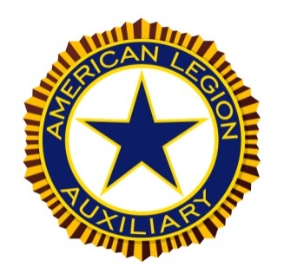
AMERICAN LEGION AUXILIARY

Hello all, I hope everyone had a great Thanksgiving with family and friends.

Welcome to our two newest members, sister’s Bridget and Kathleen. We are now at our 100% goal with 48 members paid.

Our annual wine and beer tasting went off as usual without a glitch. It is amazing how that team can transform the legion into a truly elegant setting for our guests. A lot of time and work goes into making this event so successful and I truly thank everyone who helped this year. Many of our group instead were at the airport to welcome home two of our own veterans who went on the Honor Flight.

Our Nov 11 veteran’s day event was a HUGE success packing both rooms of the legion. Thanks to all that attended, volunteered and/or donated. It was an honor for the Auxiliary to put on such a welcoming and fun celebration honoring our veterans, and it was great to see some new faces there!

Donations were put in the mail in November to support two of our favorite organizations for the holidays, Wreaths Across America and Christmas with the Vets.

The Auxiliary did not meet in November due to the Monday night Packer game, our next meeting Dec 8, the Auxiliary will hold their annual Christmas party with a potluck and white elephant gift exchange.
Many of our auxiliary team is already planning to support the January Coon Feed again, and as well planning our next event back by popular demand, the AllyUkes coming April 19th, mark your calendars.
You will soon see the legion looking much more festive with lighted holiday trees and decorations, thanks to all the ladies who make this happen every year.
Looking forward to seeing you all at the legion and supporting the other Legion events coming up.

If I do not see you in person, please have a very Merry Christmas and Happy New Year!!!

Mary Steinmueller
President, American Legion Delafield Auxiliary
Honor our Country, Support our Veterans

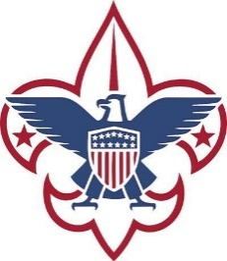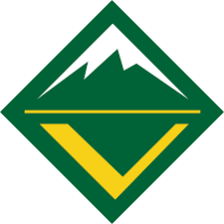

Troops 49B & 49G, Crew 196 & Pack 196 Report

(There was no report for December)


Chaplains Corner - December 2025

Dear friends,

Christmas is a season of gifts—sometimes wrapped in paper, sometimes wrapped in love. One of the greatest gifts we can give is remembrance.

I once told the story of two little boys who wanted to change how they called their father—one choosing “Dad,” the other holding onto “Daddy.” What struck me most was not the words themselves, but the love behind them. Whether we call upon God as “Father,” “Lord,” or even “Abba”—that tender word for “Daddy” that Jesus Himself used—we are reminded that we are His children.

This season, let us remember those who cannot be home to say “Dad” or “Mom” at the supper table. Let us remember the men and women serving in uniform right now, far from family. Let us remember our disabled Veterans, who carry the scars of service every day. And let us remember those still unaccounted for—our POWs and MIAs—whose absence is felt most deeply during times of family gathering.

When we pray “Abba, Father,” we join our voices with theirs. We ask for strength for those serving, healing for those wounded, and comfort for families who wait. We ask for peace for those who never returned, and for courage to keep their memory alive.
This Christmas may our prayers be our gift. May remembrance be our offering. And may hope be our shared blessing.

“Abba, Father, amen.”

May the Lord watch over those who serve today,
heal those who bear the wounds of service,
and bring home those still unaccounted for.
May His peace rest upon us all,
as we remember, pray, and give thanks.

Take time to rest, reflect, and trust that even in the busiest moments, you are not alone. And always remember—your Chaplains are here for you.

Blessings,
Your Chaplains - Neil, Barb and Tom
Here is how to contact your Chaplain:

Contact the Legion Chaplain – Neil Rand at (262) 646-3126 nrand@wi.rr.com
Contact the SAL Chaplain – Tom Kerwin at (262) 370-7450 tkerwin@wi.rr.com
Contact the Auxiliary Chaplain – Barbara Doerfer at (414) 333-4891 jbedoerfer@gmail.com

Events Coming Up!

Sunday December 7th – SAL Chili Cookoff – 3:25pm Packer game
Sunday December 14th – Artisan Fair – 3:25pm Packer game

Watch the weekly emails for activities at the post every week!!!
PLEASE HELP US GET THE WORD OUT!! VOLUNTEERS NEEDED FOR MANY EVENTS!!

THE PUBLIC IS WELCOME!!! (That’s Legion terms for Open to the Public)
MONDAY - THURSDAY 1PM - FRIDAY at 4PM
FOOD, BEVERAGES AND COMARADERIE !!!!
BRING YOUR FRIENDS AND ENJOY - WE WOULD LOVE YOUR COMPANY
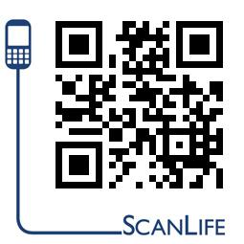

ALWAYS KEEP CURRENT WITH POST 196 AND SCAN ABOVE TO YOUR SMART PHONE
Check us out on FACEBOOK Delafield Legion Post 196 and “LIKE “ us - www.delafieldlegion.com

EDITOR’S NOTES:

Our thanks go to WKLH 96.6 radio for hosting their morning show at our post a couple of weeks ago That was early, but fun!! They mentioned our post almost every time they went live after the music and commercials ended. Thanks also to Tom Ewald from Ewald Automotive Group for sponsoring the morning show and for his generous donation to our post. We hope to do this again next year.
.
If you are looking to rent the legion hall, pavilion, or baseball field, please contact Jennifer McCarthy or email the post – delafieldlegionreservations@gmail.com . You can check the hall availability by browsing the events calendar - https://teamup.com/kseeqzbb5m37shpzdb
If anyone is still getting a paper copy of this newsletter and would like to receive it either through email or go online to our website to read it, let me know. I can help you get to the website, or I can get to you added to email if you have an address. I will still send a paper copy to those that are physically unable to pick one up. If you have a Delafield address and you are unable to pick a newsletter up at the post, you can contact me by email at GOLDFAT@AOL.COM 1
Merry Christmas to all and have a great new year!
Keith “Buff” Roeber - 2nd Vice Commander - DELAFIELD AMERICAN LEGION POST 196

